

##### **RAIN WATER HARVESTING SYSTEM**

**A PROJECT REPORT**

**Submitted by**

*Aradhya Tripathi*

*Devansh Goswami*

*Harshita Mathur*

*Hrithika Sarkar*

*Jayesh Jayanandan*

*Mimansa Sharma*

*Reshesh Kumar Pathak*

*Shivansh Singh*

***Under the Guidance of***

**Mr. S. Murugaanandam**

**(Asst Professor, Department of Information Technology)**

**FACULTY OF ENGINEERING AND TECHNOLOGY**

**SRM INSTITUTE OF SCIENCE AND TECHNOLOGY**

**SEPTEMBER 2021**

**TABLE OF CONTENTS**

| **S.No** | **Title** |
| --- | --- |
| **1.** | **Abstract** |
| **2.** | **Objective** |
| **3.** | **Problem Statement** |
| **4.** | **Procedure & Implementation** |
| **5.** | **System Architecture** |
| **6.** | **User Interface** |
| **7.** | **Technology Stack** |
| **8.** | **Budget** |
| **9.** | **Participants** |
| **10.** | **References** |

**Abstract**

The IoT based Water Level Monitoring System allows us to keep a regular check of water level present in the tank at different levels. One of the major problems faced by Tamil Nadu is the issue of water scarcity in the state and wastage during transmission has been identified as a major culprit. This is one of the motivations for this research, to deploy computing techniques in creating a barrier to wastage in order to not only provide more financial gains and help the environment as well as the water cycle which in turn ensures that we save water for our future.

The IOT based Water Level Monitoring system is an innovative system which will inform the users about the level of liquid, and will prevent it from overflowing. It will also provide timely information regarding flow rate of water and ph level. To demonstrate this the system makes use of containers, where the Water Flow Sensor is placed over the containers to detect the liquid level and compare it with the container’s depth. The system makes use of an ESP32 microcontroller, cloud support as well as a backend used to monitor and track various water specifications. Thus this system helps to prevent the wastage of water by informing about the liquid levels of the container.

**Objective**

To create a RainWater Harvesting System for schools which extracts details about the water level and the quality of water from each RainWater collection device and makes the data readily accessible on all devices.

**Problem Statement**

Tamil Nadu Govt. approached SRMIST, Chennai, with a proposal to develop an IoT based solution which tracks all details from rainwater collection systems and displays details such as water collected daily, FlowRate of the water, pH level etc.

**Main Goals** -

1. Daily Water Level Tracking

2. Reduce Unnecessary Wastage of Water in the City

3. Easy Accessibility to Data

**Key Requirements** -

1. IoT System to collect data

2. Secured Application

3. Robust & Reliable

**Procedure**

**Registration**

Schools and institutions can register on the website to have an IoT device allotted to them which will in turn be sent in order to monitor their water usages and provide statics, send alerts as well.

**Login**

Schools and institutions can also login to the website using the password and email set during registration and monitor their water usage, receive real time alerts as well.

**Data Collection**

ESP32 microcontroller (hardware) sends data to the server periodically with all the specified parameters such as pH, volume etc.

**Analytical Dashboard**

Data is collected from the backend and appropriate graphs are plotted.

Data Displayed through the charts will be for:-

* line Chart - flow rate of the water collected through rain harvesting.
* water quantity - a line chart to display the quantity of water stored in the tank.
* pH value - a bar chart to display the pH value of the water collected through rain-water harvesting**.**

**Alert Notifications**

In case of an anomaly ESP32 microcontroller (hardware) sends a request to the server which is sent to the dashboard via a socket connection in order to alert the end user.

**Table**

Display the cumulative data of last 30 days in a table comprising of

* Date
* Volume of water (litres)
* flow rate (litres/second)
* pH
* Chlorine Content (mg/litre)

**Microcontroller- ESP32**

Data is collected from the respective sensors and stored on local memory.

ESP32 is connected to internet via 2.4ghz wifi

Data is uploaded to the server at a 24 hour interval and after successful upload, data is cleared from local memory

Specifications**:**

Sensors - Water level, Ph, Flow rate sensor

Logic Level - 3.3v

Input Voltage - 5v

**System Architecture**

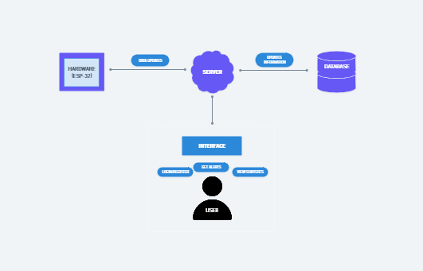

**User Interface**

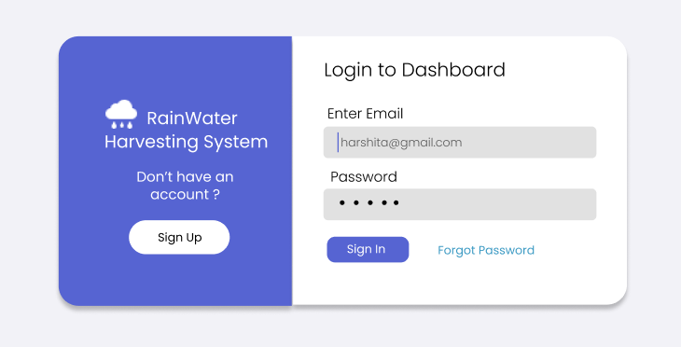

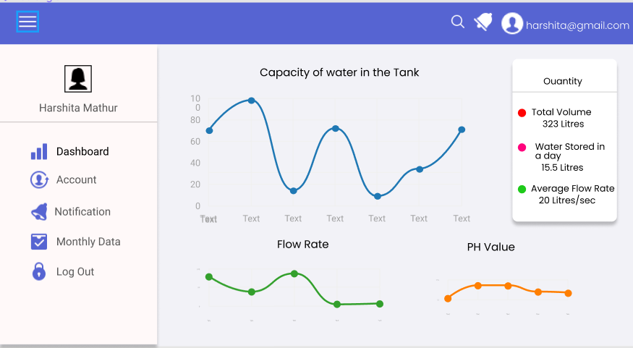

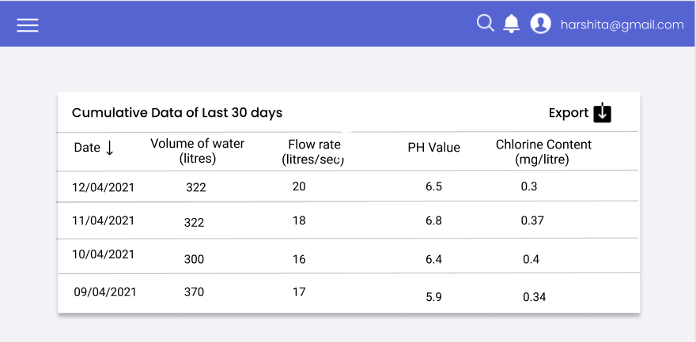

**Technology Stack**

**Frameworks:**

* Django
* Redis
* React Js
* Recharts.Js
* Redux

**Database**

* MongoDB

**Server**

* AWS LightSail

**Participants involved in Project Implementation**

| **Name of Participant** | **Registration Number** |
| --- | --- |
| **Aradhya Tripathi** | **RA1911004010187** |
| **Devansh Goswami** | **RA1811003010569** |
| **Harshita Mathur** | **RA1911003011005** |
| **Hrithika Sarkar** | **RA1911003010674** |
| **Jayesh Jayanandan** | **RA1911003010006** |
| **Mimansa Sharma** | **RA1911003010296** |
| **Reshesh Kumar Pathak** | **RA1911043010077** |
| **Shivansh Singh** | **RA1911032010008** |

**Resources and Budget required for the project**

**Budget for RWH SIIC**

**Hardware Requirements (erroneous components)**

1. Microcontroller with Wifi - Rs.600 (ESP32)

2. Sensor flow meter- Rs1500 [[Sensor](https://robu.in/product/dn32-water-flow-sensor-flowmeter-3-5-24v-1-25-1-120l-min/?gclid=CjwKCAjwyvaJBhBpEiwA8d38vGpQj2YkBRlDs7uhqvURF8k3dGlpUQCxOKOepVj_ePJ677ndSA1hzRoCTuIQAvD_BwE)]

3. PH sensor- Rs 1700 [[PhSensor](https://robu.in/product/grove-ph-sensor-kit-e-201c-blue/?gclid=CjwKCAjwyvaJBhBpEiwA8d38vHXVqA1ZEFQI9hpO9hwtXM6sEB7J8BqS4GOV6xlxr9e5DBKOzY6gZBoC5r4QAvD_BwE)]

4. Water Level sensor- Rs 180 (x4) [from Local Market]

5. Back up battery along with circuit set- Rs 2200 [[Backup Battery](https://robu.in/product/orange-4200mah-2s-35c-7-4v-lithium-polymer-battery-pack-lipo/)]

6. Wiring cable set- Rs 600

7. Closures for microcontrollers & Accessories for fixing devices- Rs 2000

8. 3D Printing Filament- Rs 1500 ( only 2 filaments required for all 5 units )

9. Power Supply- Rs 60 [[DC Power Supply](https://robu.in/product/lm2596s-dc-dc-buck-converter-power-supply/?gclid=CjwKCAjw7fuJBhBdEiwA2lLMYYnVIh2RQEYhOEgc60rT1PU3_uEkSMe1qhneYB5PX8F6yEPXvvnaXRoCJGEQAvD_BwE)]

**NOTE**: For 5 hardware units, the total budget will be multiplied by 5 which is estimated to be Rs50,000.

**Server-Side Requirements** 10. AWS(Cloud Support)

* LightSail - $5 x 12 = $60 per year [AWS Server & Database]
* AWS SES - $3.04 x 12 = $36.48 per year [Email Service (1000 emails per day)]
* AWS SNS - $0.02 + $0.05 ( tax inclusive) x 12 = $1.44 per year [Notification]
* Total = $96.48 + $1.44 + taxes = $100 per year [Total cloud support]

**NOTE**: Server Side Requirements and its budget will remain the same for all 5 units. Hence, there will not be any additional charges for server side.

**TOTAL TENTATIVE BUDGET:**

**Rs10,880 x 5 = Rs 50,000 (Excluding AWS charges)**

**$100 (Server Charges)**